**Experiment – 6**

**DML COMMANDS (COLLEGE SCHEMA)**

**Aim:**

* Insert 5 instances into the tables created in experiment 6.
* Display the tables.
* Add attribute course to student table then insert values.
* Use update to set course for students.
* Delete an attribute.

CODE WITH SOLUTION:

* Insert 5 instances into the each table and display

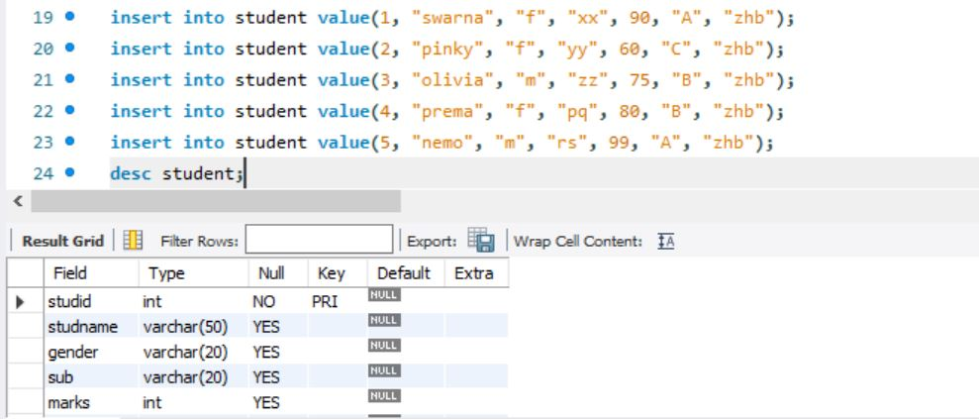

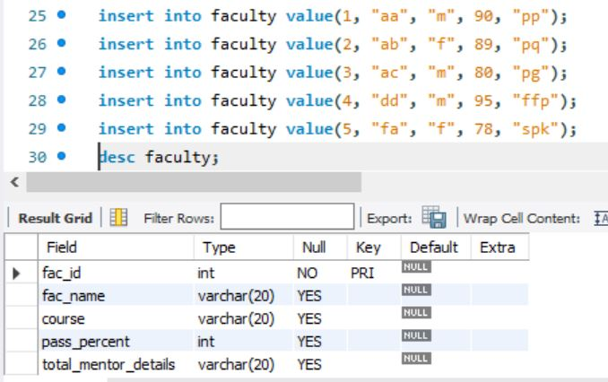

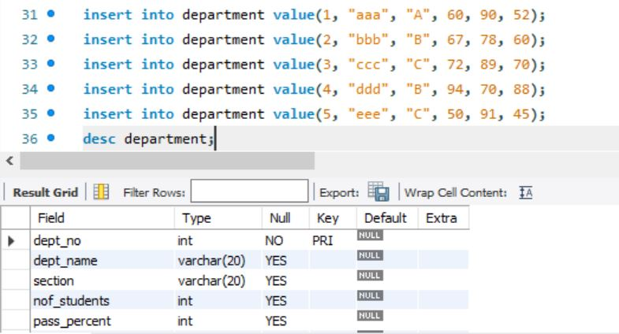

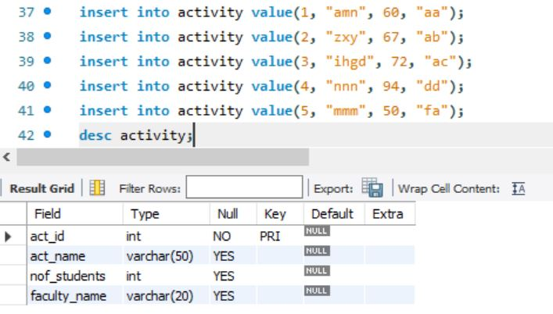

* Display tables

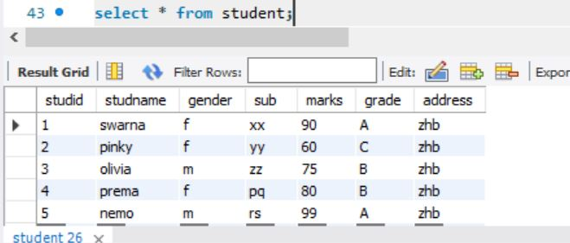

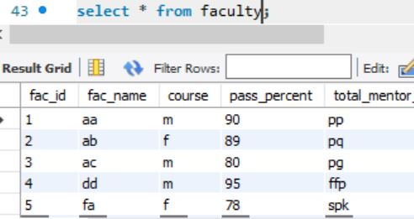

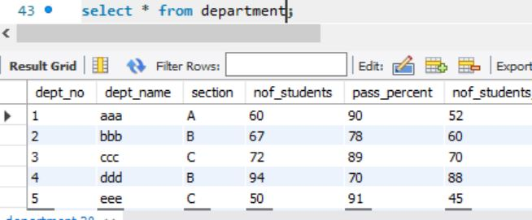

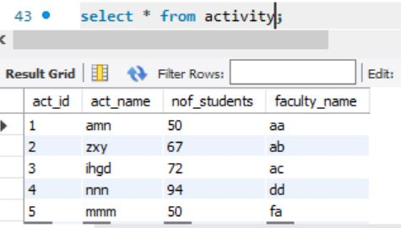

* Add attribute course to student table then insert values
* Use update to set course for student

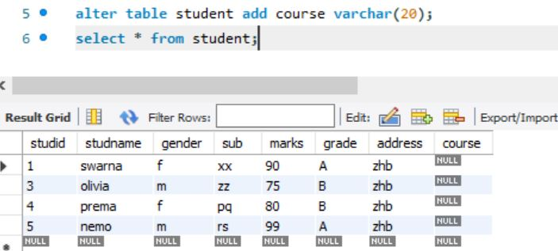

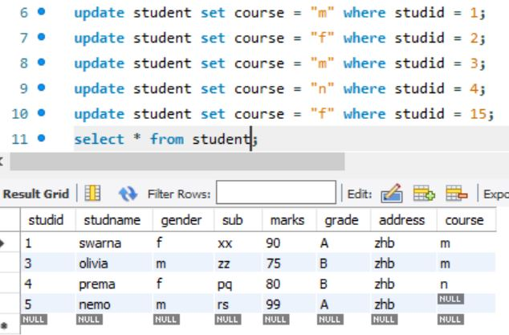

* Delete an attribute

